|  |  |  |
| --- | --- | --- |
| EUFOR LOGO FINAL 11 | **PROCUREMENT AND CONTRACTING OFFICE**  HQ EUFOR, J8  BUTMIR Camp Sarajevo  Bldg. 225, 71210 Ilidza, BH  Fax: +387-33-495707  e-mail: [taco@eufor.europa.eu](mailto:taco@eufor.europa.eu) | EUFOR LOGO FINAL 11 |

**CLARIFICATION 1**

**Invitation for bidding for supply and delivery of accommodation and office furniture for Camp Butmir Sarajevo**

**Publication reference: HQ EUFOR/ACCOMODATION & OFFICE FURNITURE/2024-SU/006**

- In accordance with Article 2. and Article 12. of Instruction to bidders, requests for clarification are to be received by the 02 May 2024 and clarification to be issued by the Contracting Authority by 10 May 2024. The following clarification question have been received, followed by the Contracting Authority’s answers:

**Questions 1.**

Could you kindly advise if installation is part of the scope of work. If not could you please confirm that you can accept all ordered items in their original package, meaning that some of them will need assembly by you.

**Answers 1.**

All requested furniture should be delivered assembled and ready for use. It is possible to deliver furniture to Camp dismantled, however, it is supplier’s obligation to assemble it and hand it over as such.

**Question 2.**

We have checked the specifications and could supply you with all items except the chair that only IKEA can manufacture. Can we offer this model in a color that you wish?

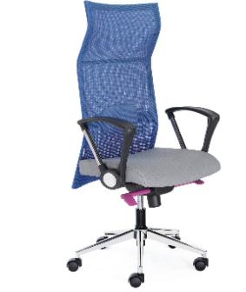

**Answer 2.**

In accordance with Annex II, Technical specifications, Line item 6. IKEA MARKUS or equivalent chair has been requested. As long as your offered chair has equivalent technical characteristics (including warranty) as referenced model (Ikea Marcus) it shall be acceptable.

Procurement and Contracting Office

J8, HQ EUFOR

10 May 2024

This clarification is being sent simultaneously to all bidders and published on following website: [www.euforbih.org/tenders](http://www.euforbih.org/tenders) where bidding dossier is published. No further clarifications may be required nor provided as specified by clause 12 of the instructions to Bidder.